# INTRODUCTION

* 1. **Overview**

The urban interior style merges industrial with contemporary design, creating a modern, bohemian look. You'll see concrete floors, exposed timber beams, steel, and unfinished surfaces. Sophisticated finishes and high-end bespoke fixtures makes the Urban look more expensive and polished. Urban design is not just a well-designed building. It includes the spaces between buildings, infrastructure, landscape elements, plazas or streetscape elements. Good urban design is central to ensuring the live ability of our cities and regional towns.

* 1. **Purpose**

As a large proportion of housing stock does not meet the current demands for energy and comfort (leading to high levels of obsolescence and vulnerability), the annual rate of energy upgrades for the existing stock must be increased. The AURA Strategy is an intervention methodology which focuses on the regeneration or obsolete urban fabrics which suffer from high levels of architectural, urban and socio-economic vulnerability. Within this context, the AURA prototype was developed for the Solar Decathlon Europe 2019 Competition through the reuse of existing buildings considering Mediterranean climate and energy. Two first prizes were won in contests with on-site measurements: Comfort conditions and House Functioning. Third place was also obtained in the Sustainability contest, thus confirming the enormous possibilities the AURA Strategy has for sustainable urban regeneration in retrofitting social housing, within the limitations of the competition.

1. **Problem Definition & Design Thinking**
   1. **Empathy Map**

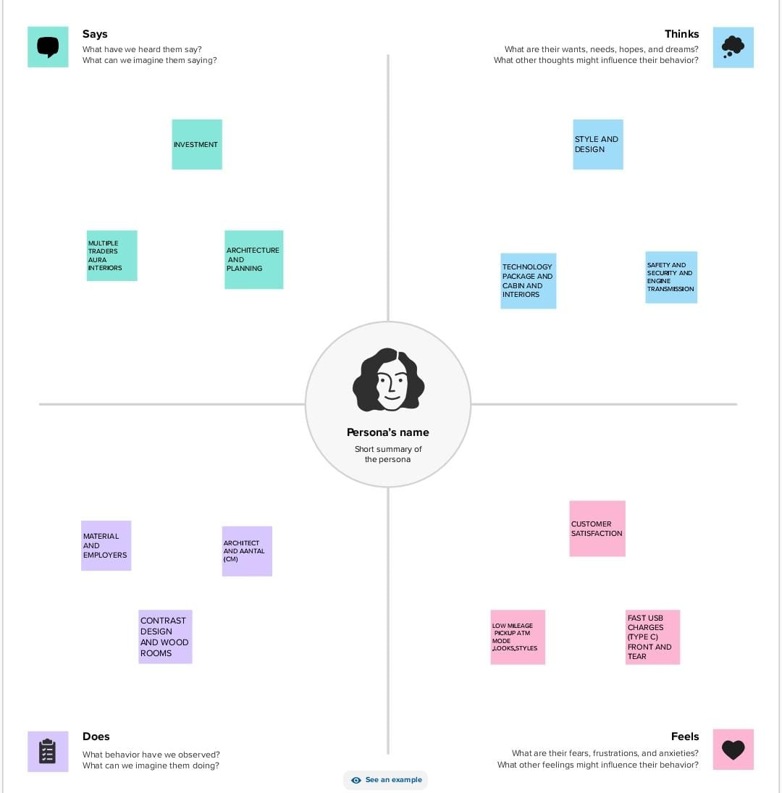

* 1. **Ideation & Brainstorming Map**

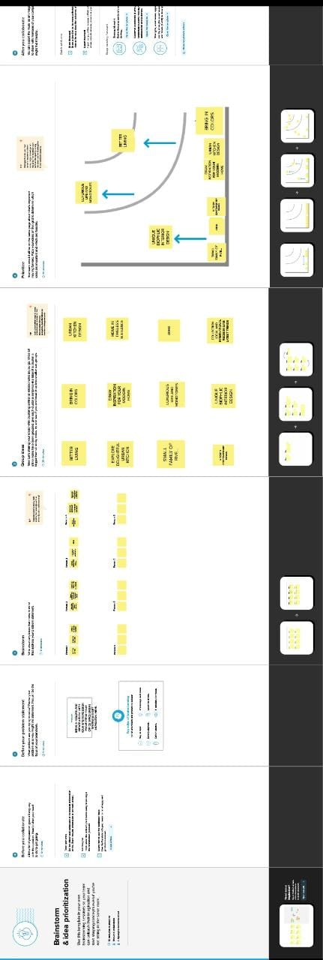

# RESULT

Communication is key We are here for whatever you need. We'll help you solidify your vision and keep in constant contact until your dream is realized Formed by a love of history, we love keeping as much of the bones of a structure as we can. Marrying in your personality is what really brings a home together.

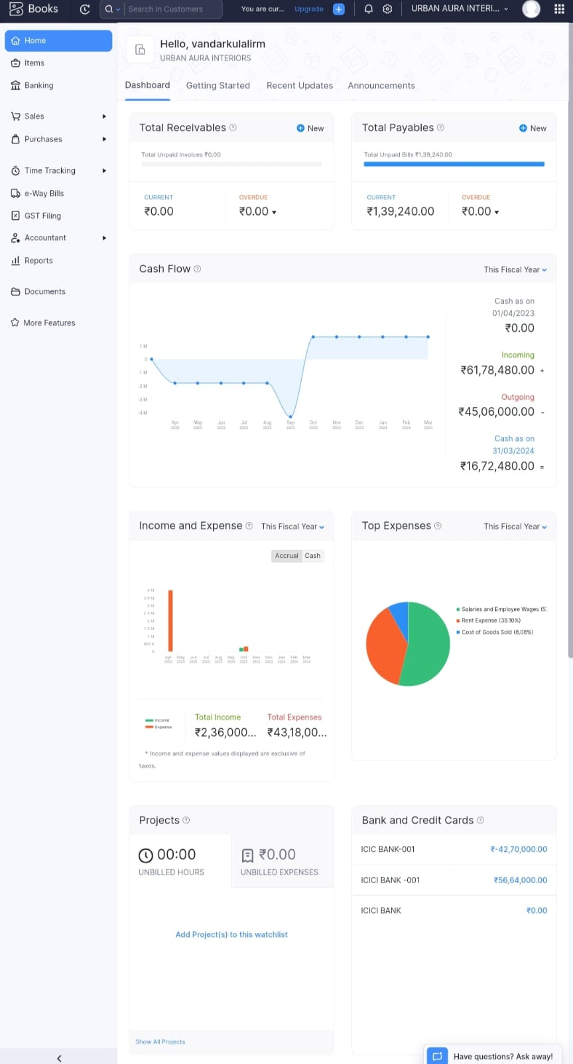

# ADVANTAGES & DISADVANTAGES

# ADVANTAGES

* Designers Are Experts....
* Designers save You Time and Money....
* Designers are Well Connected....
* Designers Tie The Entire Project Together....
* Designers Make Spaces More Functional And Appealing. ...
* Designers Deliver The Latest Trends. ...
* Designers Add Value…..

**DISADVANTAGES**

* It's a Stressful Job.Satisfying a client's specific requirements is not an easy task....
* Problematic Clients. Another one of the disadvantages of being an interior designer is that not every client will be good....
* Low Income in the Beginning....
* It Takes Time....
* Long Working Hours.
* Budget…
* Creating More Space from Thin Air. ...
* Prevent Marital Strife. ...
* Create Additional Rooms. ...
* Deal with Mom's Stuff. ...
* Elevate the Most Mundane Everyday Experiences.

# APPLICATIONS

Rent property in the heart of Bengaluru city. Property for rent available in narayanapura. No 12 months period. This property is ready to move in and is equipped with all basic amenities such as washing machine, microwave, fridge, water purifier, etc. Contact for more information. Guaranteed security and round the clock cctv surveillance facility. Inverter (No A/C Support) available with this big, spacious property offered at affordable rent. Separate lift for staff and servants. It is a and has provision for two wheeler, etc. Very close to English-medium, convent school, Rashtrotthana Vidya Kendra, Hegemony Global School, and EuroKids Pre-School. REGAL Kidney and Multi Specialty Hospital, Bengaluru, Cratis Hospital, and SUNSHINE HOSPITAL are within walking distance.

# CONCLUSION

In recent years, the sub-4 meter sedan has evolved into one of the most popular and highly competitive segments in India. Hyundai launched the [Aura](https://www.cardekho.com/hyundai/aura?isLeadOpen=True" \t "_blank) sedan in Jan 2020 and in a short span of six months, the car has emerged as a leader in this class. What makes the car truly special is that it offers the best of both the worlds, technology and practicality in a segment marred with compromises.

Here’s how the Hyundai Aura is leading the pack of compact sedans by offering the perfect blend of technology, features and comfort at an attractive price tag.

# FUTURE SCOPE

Quite sometime ago, images of an updated ***[Hyundai Aura](https://indianautosblog.com/hyundai-aura.html" \t "_blank" \o "Hyundai Aura news)*** - the most prominent update being a new rear spoiler - were seen floating around on the internet. ***[Hyundai](https://indianautosblog.com/car-news/hyundai" \t "_blank" \o "Hyundai news)*** have now silently updated the 2021 Aura sub-compact sedan with a feature rejig along with a price hike of INR 4,000 for all variants apart from the base E variant. Prices for the Hyundai Aura currently start from INR 5.97 lakh and go up to INR 9.35 lakh (ex-showroom). The Hyundai Aura is available in five variants..

